Project Design Phase-II
Data Flow Diagram and User
Stories

Date | 8 February 2026
Team ID | LTVIP2026TMIDS43288
Project Name | Project – Online Payments Fraud Detection Using Machine Learning
Maximum Marks | 4 Marks

Data Flow Diagram
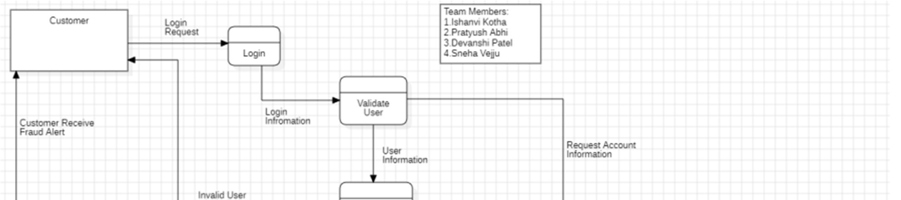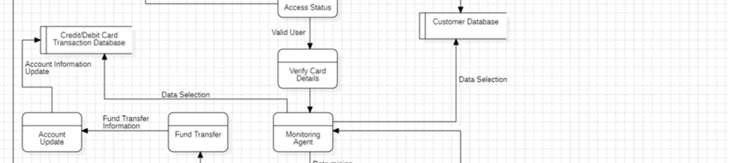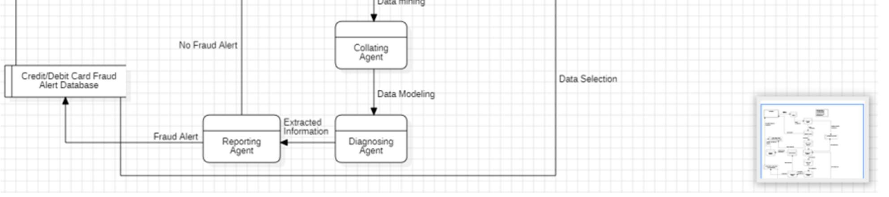

User Stories

User Type | Functional  Requirement  (Epic) | User  Story  Number | User Story / Task | Acceptance criteria | Priority | Release
Fraud Analysts | Project Setup & Infrastructure | USN-1 | Set up a dedicated fraud detection environment with necessary tools and frameworks to initiate the project. | Successfully configured environment with all required tools. | High | Sprint - 1
Data Scientists | Data Collection | USN-2 | Curate a comprehensive dataset of historical online transactions, including both legitimate and fraudulent examples. | Gathered a diverse dataset representing various transaction types. | High | Sprint - 1
Data Analysts | Data  Preprocessing | USN-3 | Preprocess the collected dataset by handling missing values, outliers, and ensuring compatibility with machine learning algorithms. | Successfully preprocessed the dataset. | High | Sprint - 2
Machine  Learning  Engineers | Model  Evaluation | USN-4 | Explore and evaluate different machine learning algorithms to select the most suitable model for online payments fraud detection. | Explored various machine learning models. | High | Sprint - 2
Security  Administrators | Model Training | USN-5 | Train the selected machine learning model using the preprocessed dataset and monitor its performance on a validation set. | Conducted successful training and validation of the model. | High | Sprint - 3
Software  Developers | Model  Optimization | USN - 6 | Implement techniques to optimize the model's performance, reduce false positives, and enhance its accuracy in real-time scenarios. | Improved model performance with reduced false positives. | Medium | Sprint - 3
IT Operations | Model  Deployment & Integration | USN - 7 | Deploy the trained machine learning model as an API for real-time fraud detection. Integrate the model into a user-friendly interface for administrators. | Checked the scalability and accessibility of the deployed model. | Medium | Sprint - 4
Quality  Assurance  Engineers | Testing &  Quality  Assurance | USN - 8 | Conduct thorough testing of the model and user interface. Identify and report any issues or bugs. Fine-tune model hyperparameters based on feedback. | Created a web application and  optimized model based on testing results. | Medium | Sprint - 5

